2.

Mobile phones are used by many people for many different purposes. Having access to a telephone in the event of an emergency can be very helpful. Staying in touch with friends and family by texting or calling them. Or using mobile phones for having a phone call meeting and other types of business interactions.

3.

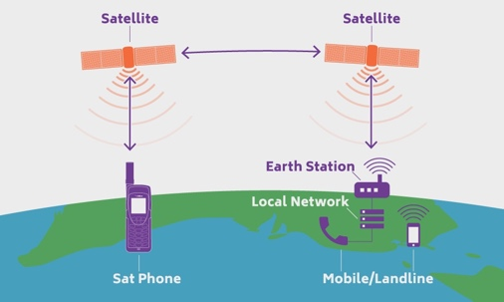

In a phone call your voice is converted into electrical signals which is then sent in radio waves to the nearest cell tower, then to the other person.

4.

Advantages:

-Staying connected to the world. Connected with friends and family or keeping up with news and what’s happening around the world.

-There are many things that are helpful on a mobile phone. Like making phone calls, using the camera, using the calculator and many more.

Disadvantages:

-Mobile phones can be a distraction to some people. By getting kids hooked to the phone and never going outside and getting any exercise. Distracting them from work and not earning money.

-Mobile phones can cause a lot of diseases from the radiation coming out of it. They can cause skin cancer, and eye problems.

5.

Mobile phones have had a huge impact on society. People are so addicted to their that they check them every 5 minutes roughly. It can make people a lot more anti-social, and have trouble with speaking to people in public. It also distracts people from doing a certain task whether it be doing homework or work for your job, it makes it harder to concentrate.

6.

I think in the future a lot more people will have a mobile phone and the advancements in technology will make phones even smarter and powerful. But with these advancements in technology come some dangerous things, like your phone listening and watching to everything you do or say. People can hack into your phones and get all your personal details. That’s why we have to be careful with technology.

7.

Bibliography:

<http://www.pewinternet.org/2012/11/30/part-iii-the-impact-of-mobile-phones-on-peoples-lives/>

<http://www.meritsdemerits.com/advantages-disadvantages-mobile-phones-points/>

<https://pongcase.com/blog/cell-phones-work/>

<https://www.outdoria.com.au/blog/satellite-phone-buyers-guide>

<https://venturebeat.com/2017/06/13/5-billion-people-now-have-a-mobile-phone-connection-according-to-gsma-data/>